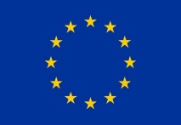
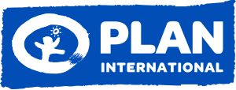
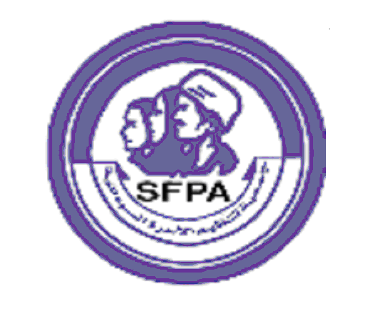
Consultant Terms of Reference

Plan International Sudan, Kordofan Program Area, Mid-Term Review TOR for
“Abandonment of FGM in North Kordofan” Project

Introduction to Plan International Sudan:
Plan International is an independent development and humanitarian organization that advances children's rights and equality for girls. In Sudan, Plan International has been working for more than 40 years, building powerful partnerships with and for children in over 300 communities in White Nile, Kassala, North Kordofan and North Darfur. In South Kordofan, Gedarif, East and West Darfur, projects are implemented through partner organizations.

Plan International Sudan is implementing its new Country Strategy which covers the five-year period from June 2018 to May 2022. The strategy will guide Plan’s work for the 5 years in line with the government of Sudan’s development, the Sustainable Development Goals, and the child rights agenda with specific focus on the rights of girls and excluded groups. Our overarching goal is to ensure that “Vulnerable children and youth are able to realize their full potential within protective and resilient communities which respect and promote girls’ equality”. This will be achieved through five strategic objectives:

- Vulnerable Children 6-14 years particularly girls and young women complete quality gender responsive and inclusive formal and non-formal basic education to succeed in life.
- Vulnerable Young people particularly young women (15-35 years old) are able to decide on their lives and lead in economic, social and civic life of their communities.
- Vulnerable children particularly girls and young women live in communities free from all forms of violence, traditional harmful practices and gender discrimination and are able to take decisions on their lives.
- Vulnerable children particularly girls 0- 5 years grow up equally valued and cared for to thrive in communities and societies that respect child rights and equality.
- Vulnerable children, especially girls, live in resilient communities and have free and safe access to life-saving services during and after natural disasters and conflicts.

The objectives are utilizing the community and individual level mobilization to promote the attitudinal and behavioral changes which are required to support transformational change for the improvement in the situation of child rights and gender equality in Sudan.

We aim to strengthen the capacity of communities, children and youth to lead their own development, and to this end we will support civil society and local organizations to monitor and support the implementation of policies and laws that create a conducive environment for the attainment of child rights, and those that pertain to girls and young women.

Project Overview:
The project “Abandonment of FGM in North Kordofan” is designed to respond to women and girls affected by Female Genital Mutilation (FGM). Men and boys will likewise be targeted through the project to ensure support their support for the goodwill of women and girls.

This will be achieved through the inclusion of both men and women in Community Based Child Protection Networks (CBCPNs), targeting religious and community leaders, targeting both male and female state level parliamentarians, legislative council members, and ensuring support for gender equality issues during training and awareness raising activities. A state level advocacy will simultaneously be conducted to strengthen the capacity of legislative council members for advocacy, to enable passing of anti-FGM laws and their implementing policies. Moreover, the state-level FGM network will be targeted to ensure continuation of their efforts, meetings, and coordination’s for the sake of FGM intervention in the area.

Total timeframe of the project was 36 months, beginning from October 2018 to January 2021, targeting an estimated of 180,000 persons in 60 communities and 2 localities (Sheikan and West Barra of North Kordofan). Some of the direct targeted beneficiaries included:

1. 90 actors from civil society organization (50 females/ 40 males)
2. 300 community promoters (200 females/ 100 males)
3. 30 singers Hakamat and 30 midwives
4. 150 community members for exchange visits (75 females and 75 males)
5. 600 members of community-based child protection networks (300 females/300 males)
6. 120 parents (60 fathers and 60 mothers)
7. 450 adolescents and members of youth groups/clubs (150 females/ 300 males)
8. 130 religious leaders (males)
9. 60 members of local government as legislative council members (15 females/ 45 males)
10. 60 members of law enforcement bodies: judges, lawyers, legal advisors (40 female/ 20 male)
11. 30 members of the FGM/C State level Child protection Network (15 females and 15 males)
12. 60 members of the Child Marriage and FGM/C Network (48 females and 12 males)
13. 60 community leaders (15 females and 45 males)

Indirect beneficiaries included those who are targeted for activities of awareness raising in the entirety North Kordofan State, such as civil society actors and activists, parliamentarians and legislative council members, children and youth, religious leaders, community leaders and community-based child protection networks for lobbying and advocacy.

The action has been designed jointly by Plan International as the lead applicant and SFPA National counterpart in close consultations with UNICEF, UNFPA (Plan's technical partner) and SCCW.

Consultancy:
- Objective:
The objective for this consultancy is to generate an analysis and a final written report of the Mid-Term Review for the ‘Abandonment of FGM in North Kordofan’ project. This analysis and report will be based on the findings generated by the Plan International team from Mid-Term Review activity. (Plan International Mid-Term Review team will be using tools such as workshop reports, focus group discussions, desk review, literature review, Key Informant Interviews etc.)

- Duties and responsibilities:
The consultant will work under the overall guidance of the Plan International Sudan M&E specialist who will be the focal person for this Mid-Term Review exercise. The consultant will conduct desk review to analyze the information and data collected and produce a situational report that accurately reflects the current implementation status.

- Proposed Time Frame:
The consultancy will involve 2 weeks’ worth of work to be completed at the latest by 29th April 2021. A draft report should be submitted to Plan International Sudan no later than 6th of May 2021.

- Output:
A draft written report and analysis will be produced by the consultant at the end of exercise. Plan International Sudan M&E team will review and produce feedback. A final report incorporating received feedback should then be submitted at the end of two weeks from that date.

Time Frame and Deliverables:
Mention what are the expected contents of the report, and if a summary report in Arabic will be required.

Activities | # of day
Desk review of relevant project documents and reports | 2 days
Review findings of KII and FGDs | 2 days
Review meeting with project teams | 2 days
Data analysis and draft report Writing | 3 days
Development and share the first draft report | 2 days
Feedback on the draft report | 2 days
Preparation of the final report by incorporating feedback on the draft report as appropriate | 2 days
Share the report with GNO to be submitted to EC Delegation | 2 day

Competencies:
- Professionalism: Ability to rapidly analyze and integrate diverse information from varied sources. Ability to produce a variety of written communications products in a clear, concise style. Shows pride in work and in achievements; demonstrates professional competence and mastery of subject matter; is conscientious and efficient in meeting commitments, observing deadlines and achieving results; is motivated by professional rather than personal concerns; shows persistence when faced with difficult problems or challenges; remains calm in stressful situations.

- Planning and Organization: Demonstrate effective organizational skills and ability to handle work in an efficient and timely manner.

- Teamwork: Excellent interpersonal skills, including ability to operate effectively across organizational boundaries; ability to establish and maintain effective partnerships and working relations in a multi-cultural, multi-ethnic environment with sensitivity and respect for diversity.

- Communications: Excellent communication (spoken and written) skills, including the ability to convey complex concepts and recommendations to staff at senior levels, both orally and in writing, in a clear, concise style.
Qualifications:
- Education: Advanced university degree advanced degree in Social Science, Economics, International Studies or related fields. A first-level university degree in combination with qualifying experience may be accepted in lieu of the advanced university degree.

- Experience: At least seven years at the national and international levels in the social changes issues such as FGM and bad practices issues of protection focusing on GBV.
Track-record of previous similar expertise with high-quality assessments, analyses and project reviews of social change communication, using the Review Tools listed above.
Proven ability to publish concise, focused, well-written and clear research/studies, assessments, and project review reports.

- Language: Fluency in written and spoken English and Arabic language. Ability to produce well-written reports in English.

Application Process:
Interested Consultants must submit the following documents:
- Cover Letter
- Curriculum Vitae of the consultant
- Sample of previous work and supporting documents of the required expertise detailed under ‘Qualifications’ section
- Technical Proposal
- Tentative financial offer (budget) detailing consultancy fees/costs

Close consultation with Plan International Sudan at every step of the process will be maintained and reporting on progress is required and should be built into the consultants’ work timeline. The consultant will be reporting to the North Kordofan Program Area Manager or his/her delegate. The consultant will need to share an outline/proposal for their work, to be approved by Plan International Sudan prior to the implementation.

Submitted proposals (maximum 7 pages) should cover the following aspects:
- Detailed response to the TOR.
- An indicative schedule/work plan with timeline
- A data protection plan and data quality assurance plan
- A profile of the consultant/consulting firm including the full names, physical addresses, telephone numbers, and contact person of the firm
- Firms capacity and relevant experience
- A statement of availability and commitment to undertake and complete the consultancy within the set time
- References of previous 3 clients.
- Copy of previous study works
- Detailed itemised budget, including daily fee rates, expenses, taxes etc. (this should include consultant fees, administrative expenses, and tax obligations). Please note Plan will not provide any logistics for this task.

Please send your application and attached supporting documents to Plan International Sudan via e-mail to: Ahmed.Ibrahim@plan-international.org, copy: hanadi.mohammed@plan-international.org with “Abandonment of FGM in North Kordofan – MTR Consultancy” in the Subject Line by no later than 4:30 p.m. on the 1st April 2021 or as hardcopy, with the title “Abandonment of FGM in North Kordofan – MTR Consultancy” on the envelope. Any emails or envelopes without the proper subject line and supporting paperwork will not be reviewed.

